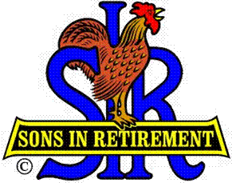

Las Trampas Branch 116

Executive Committee Meeting Agenda

September 18, 2017
9:30 AM
- Call Meeting to Order and confirm we have a quorum.
- Review Agenda/Minutes for Changes/Additions.
- Standing Reports:
Secretary – Fred Schafer – Approval of July 17, 2017 minutes.
Attendance – Sam Beret
Head count, missed luncheon receipts.
Membership – Phil Goff
New Members to be inducted:
Guests Today:
Visitors:

- Budget – Jim Nickles

- Big Sir Report:
- Storyteller: Fred Schafer
- Chaplain: Doug Alders
- Annual Corporate Meeting – August 8, 2017.
- HLM Award and Senior SIR Awards.
- Carson City Golf Tournament
- 2017 State Training

- Little Sir Report:
- September Speaker: Mark Jordan – Eclipse and its historical significance.
- October Speaker:
- Other

- Other Reports

- Adjourn – 10:15 am

